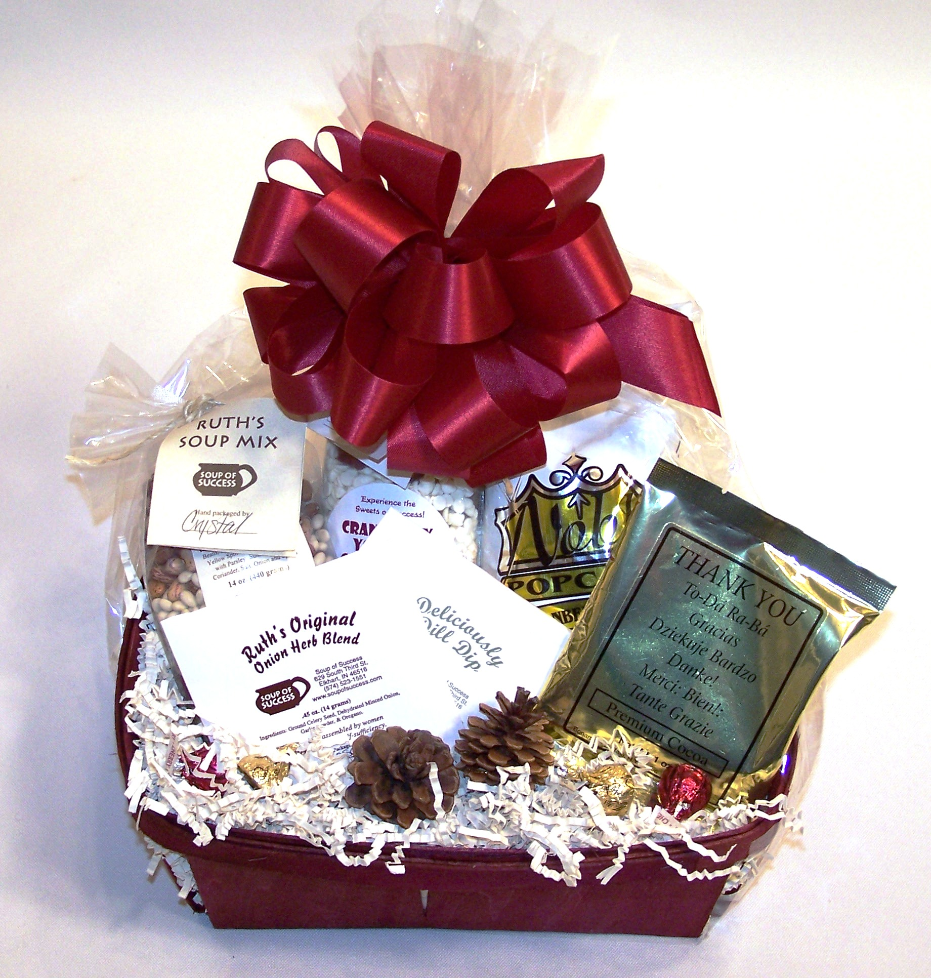
Soup of Success Gourmet Gift Baskets
Make a positive impression.
Give the gift that gives back to the community.
Choose the gift basket contents from the items below:

No. Soup Mixes - $5.00
____ Ruth’s 5 Bean Soup
____ Sensational Split Pea Soup
____ All American Chicken & Stars
____ Positively Potato Soup

Cookie/Brownie Mixes - $5.00
____ Chocolate Cherry Supreme Cookies
____ Vanilla Hazelnut Cookies
____ Cranberry Yogurt Cookies
____ Grandma’s Ultimate Apple-Cinnamon
Oatmeal Cookies
____ Chewy Chocolate Peanut Butter Cookies
____ Double Chocolate Kiss of Mint Cookies
____ Turtle Brownies

Dip/Dressing Mixes - $2.00
____ Deliciously Dill
____ Spinach
____ Ruth’s Original Onion/Herb Blend
____ Sizzlin’ Santa Fe
____ French Crème
____ Salade Mediterranean

Order Information
Customer Name: ____________________________
Customer Billing Address: _____________________
Customer City/State/Zip: ______________________
Customer Phone #: __________________________
Recipient Name: ____________________________
Recipient Address: ___________________________
Recipient City/State/Zip: ______________________
Date to be Delivered By: ______________________
Message on Gift Card:



No. Candles - $7.00 (includes tax)
Please go to www.soupofsuccess.com/candles.htm
for candle scents.
____ Scent: _________________________

Miscellaneous Items
$0.50
____ Single-Serve STASH Premium Teas
____ Ghirardelli Chocolate Squares
$1.00
____ Gourmet Cocoas, Teas & Coffees
____ Chocolate Stirring Spoons
____ Biscotti
____ Jelly Belly Candies
____ Chocolate-Dipped Pretzel Sticks
____ Marshmallow Pops
____ Wooden Spoons & Spatulas
____ Kitchen Utensils
$2.00
____ Ghirardelli Gourmet Coffee Bricks
____ Pretzels
____ Popcorn
Seasonal - $1.00
____ Ornaments
____ Placemats

List the amount of each item that you would like in your gift basket, and we will create your customized gift basket with an appropriately-sized basket (which range in price from $4 - $10)! We ship UPS; shipping ranges from $4 - $8. We invoice you and accept check or credit card (MasterCard or Visa).

You can order gift baskets in several ways:
- Fill out this form (one form per gift basket, unless you want several of the same gift basket) and email to: soupofsuccess@aol.com or fax to: 574-295-5593
- Email the items you would like in your gift basket to: soupofsuccess@aol.com
- Call SOS at 574-523-1551
- Visit SOS at 629 S. 3rd St., Elkhart, IN, 46516

